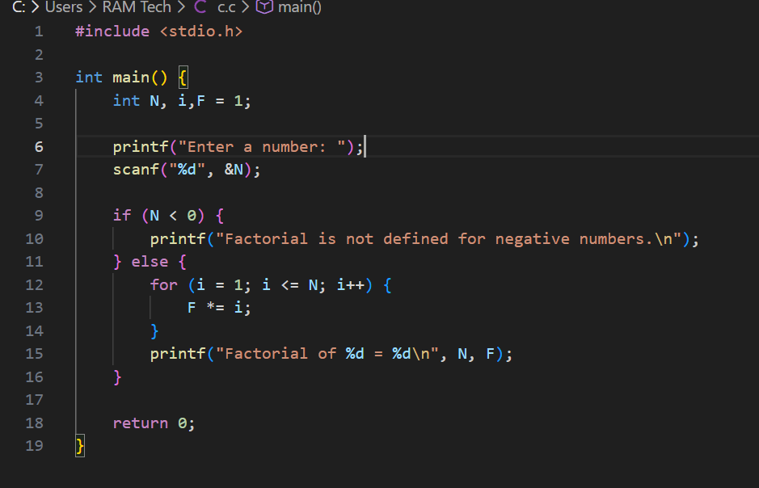
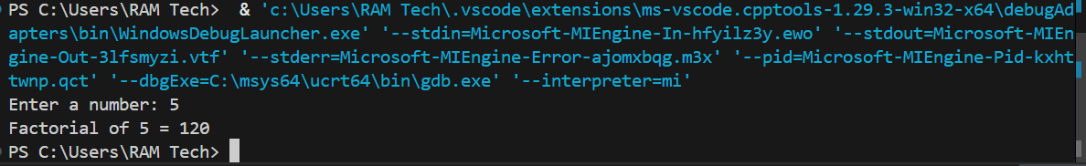
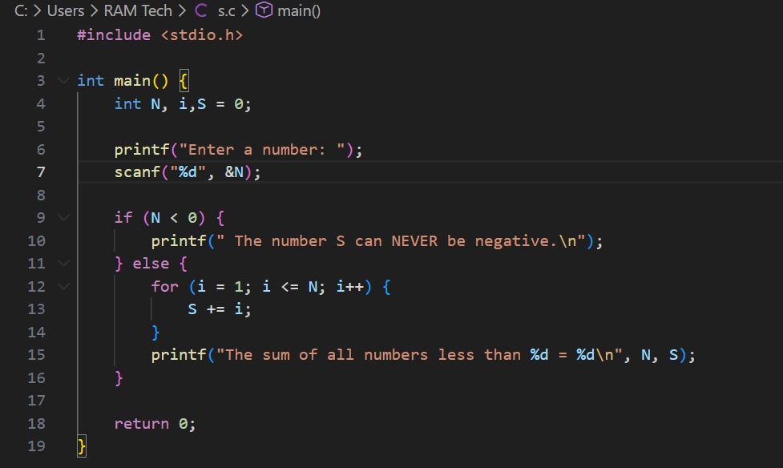
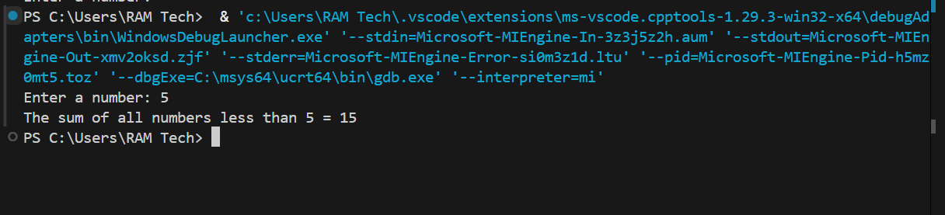
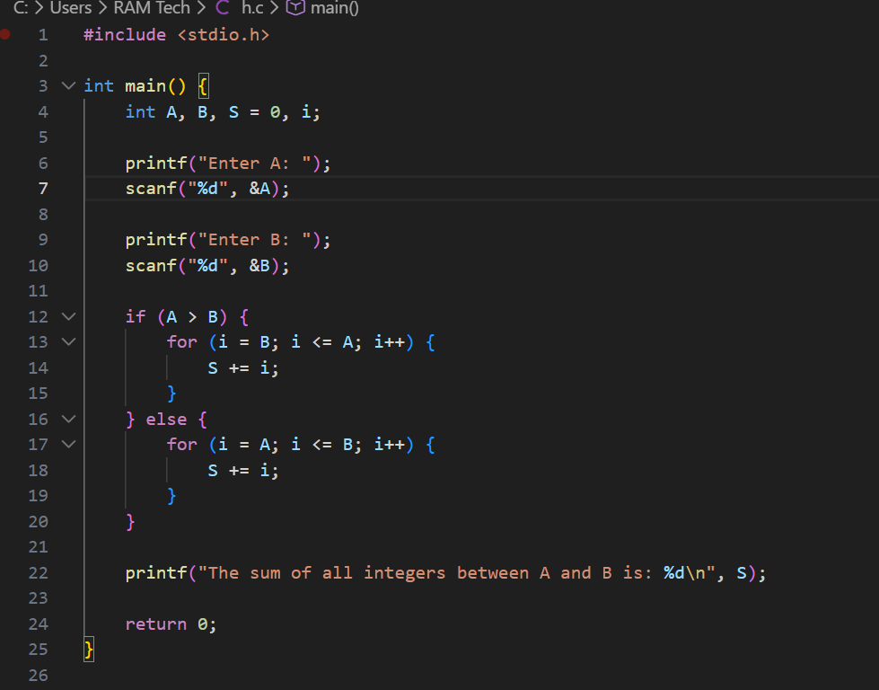
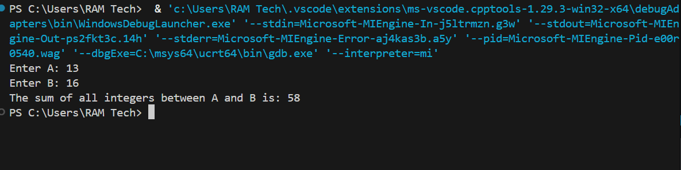
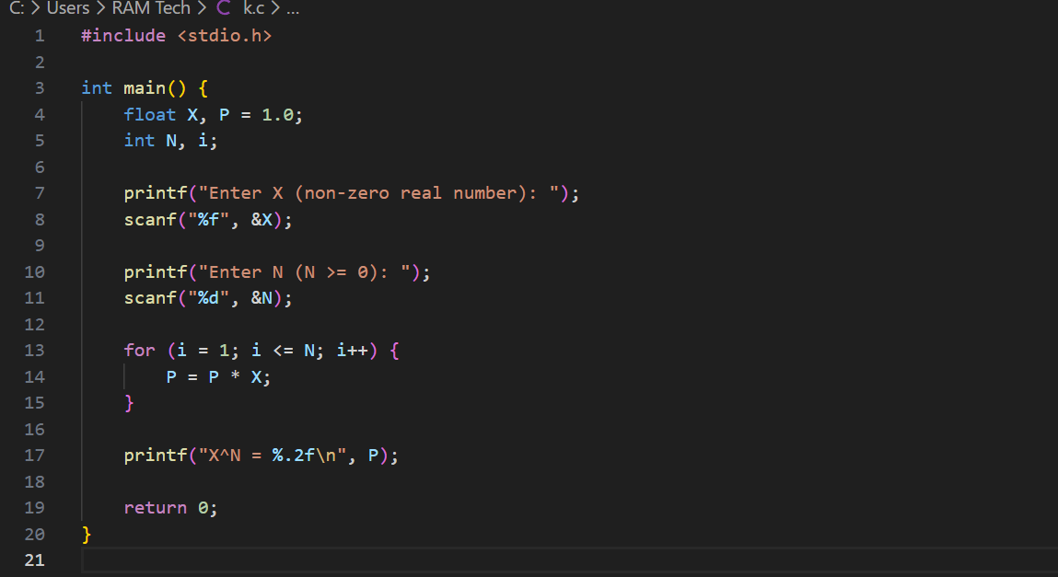
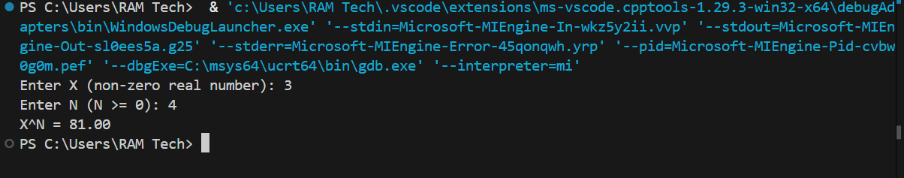
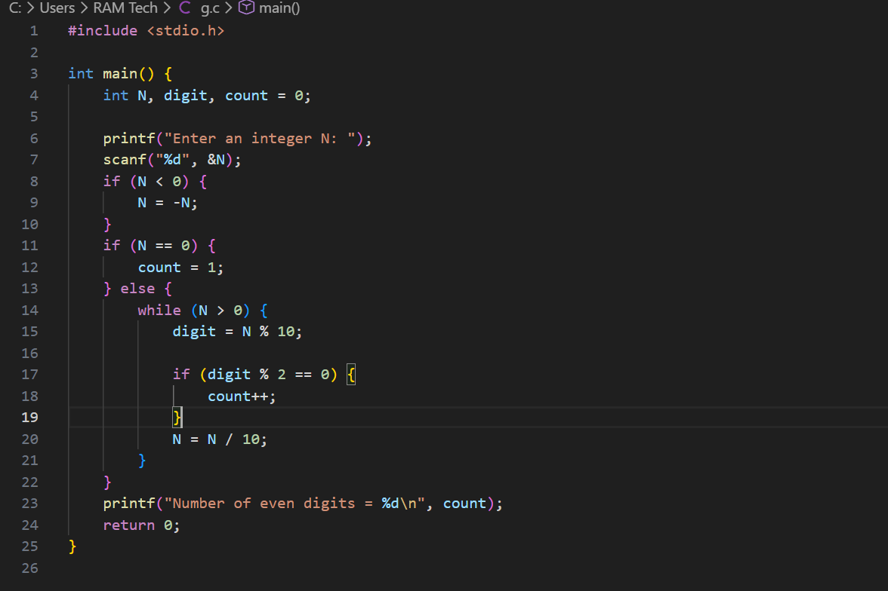
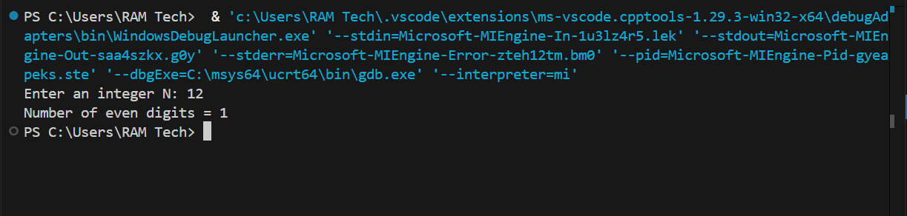
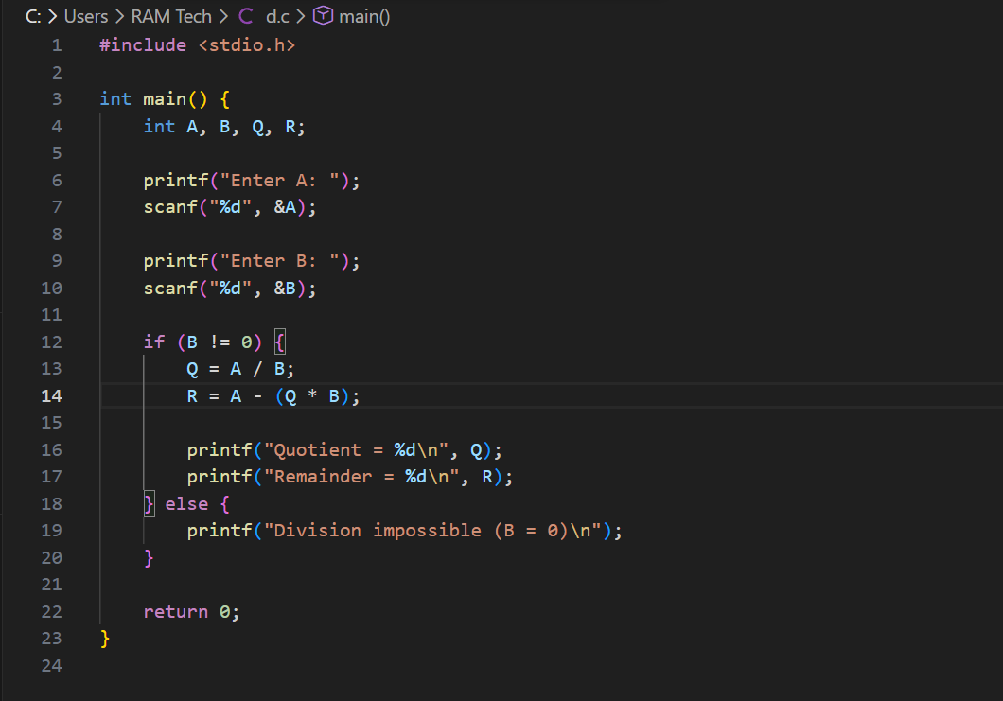
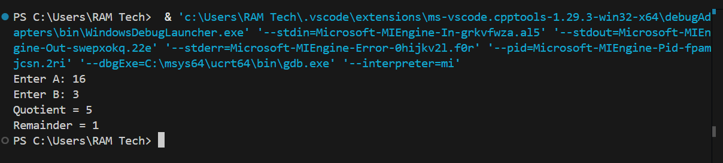
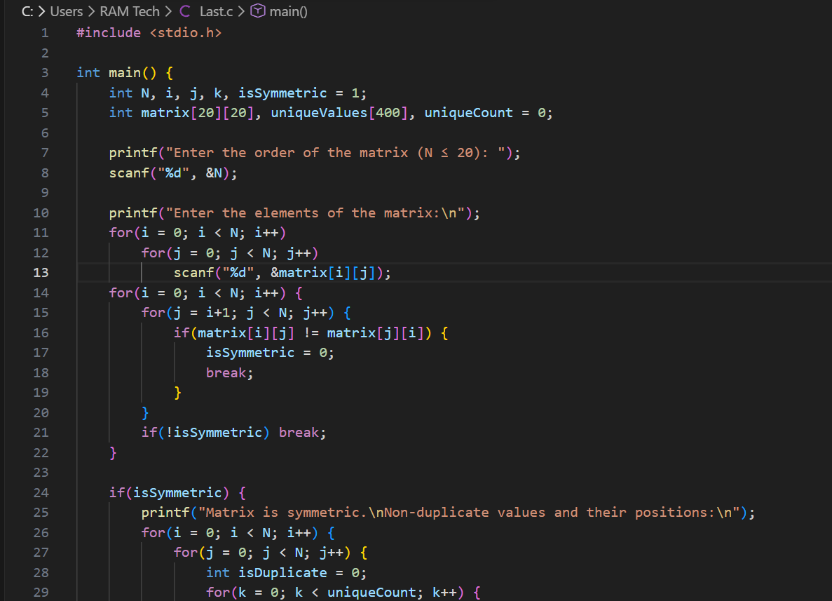
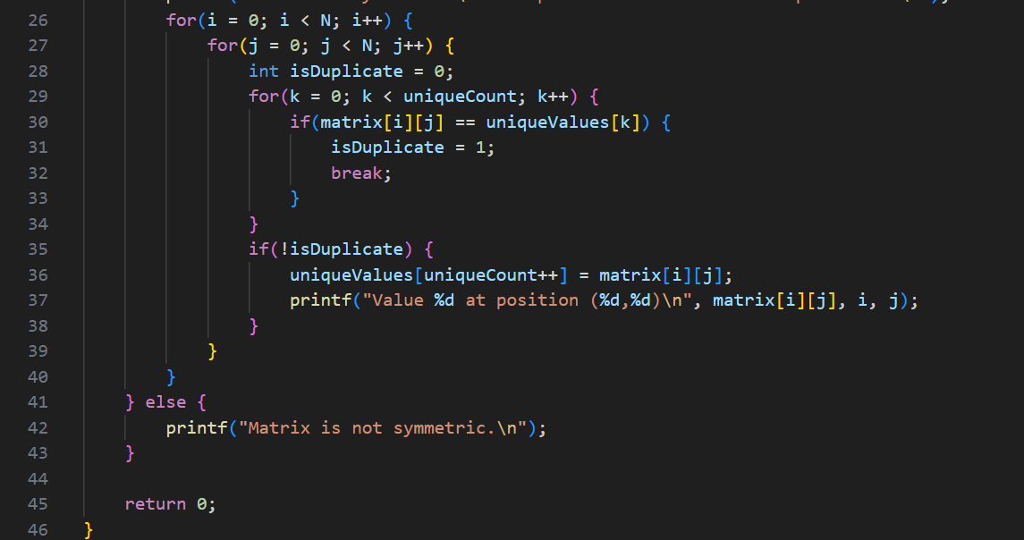
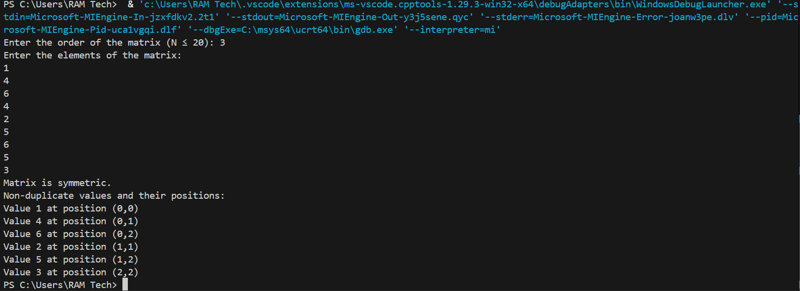
Mini Project Response sheet

 | First Name | Family Name | Groupe
Student1 | Abderrahman | Zerdouba | G01
Student2 | Mohammed El Houssein | Kadri | G05
If the student works alone put / in the case.

Module 01: Numerical Algorithms (Focus: loops, integer operations, conditions)

Write an algorithm for each of the following tasks:
- Compute the factorial of a natural number N.
Analysis :
Input | Processing | Output
Natural number N | Initialize a variable fact to 1, then multiply it by all integers from 1 to N using a loop. | Factorial of N (N!)
A

/Python Code : Put a screenshot of the course like in the course

Execution : Put a screenshot of the execution like in the course
- Compute the sum:

Analysis :
Input | Processing | Output
Natural number N | Initialize a var S to 0  Add each integer from 1 to N to S  After reaching N, output the value of S | The sum of all numbers less than N
Algorithm:

C / Python Code : Put a screenshot of the course like in the course

Execution : Put a screenshot of the execution like in the course

- A Compute the sum of all integers between two numbers and B.

Analysis :
Input | Processing | Output
A: an integer  B: an integer | Compare the two numbers A and B  If A is greater than B, exchange their values  Initialize a variable S to 0  Add all integers starting from A up to S to S  Output the value of S | S: the sum of all integers between A and B
Algorithm:

C / Python Code : Put a screenshot of the course like in the course

Execution : Put a screenshot of the execution like in the course

- Compute , where:
  - is a non-zero real number

Analysis :

Input | Processing | Output
X: a real number  N: a natural number | Initialize a variable P to 1  Repeat the multiplication N times  In each repetition, multiply P by X  After finishing the repetitions, output | P: the value of
Algorithm:

C / Python Code : Put a screenshot of the course like in the course
Execution : Put a screenshot of the execution like in the course

- Count the number of even digits in an integer N.
Analysis :
Input | Processing | Output
N: an integer number | Read the integer N  Initialize a counter count = 0  Repeat while n=!  Take the last digit using digit = N % 10  Check if the digit is even:  digit % 2 == 0  If yes → increase count  Remove the last digit:  N = N / 10  When the loop ends, display count | Number of even digits N
Algorithm:

C / Python Code : Put a screenshot of the course like in the course
Execution : Put a screenshot of the execution like in the course

- Given two integers A and B, compute:
- The quotient of the integer division
- The remainder.
Analysis :
Input | Processing | Output
A : integer  B: integer (B=!0) | Read A, B  Compute Q = A div B  Compute R = A − (Q × B)  Display Q and R | Q : integer (quotient)  R : integer (remainder)

Algorithm:

C / Python Code : Put a screenshot of the course like in the course

Execution : Put a screenshot of the execution like in the course

Module 02: Arrays and Divisibility (Focus: indexing, Array manipulation, temporary variables)

- Write an algorithm to compute:
- the Greatest Common Divisor (GCD) of two natural numbers
- the Least Common Multiple (LCM) of two natural numbers.
Analysis :
Input | Processing | Output
A: Integer (A>0)  B: Integer (B>0) |  | GCD: Integer  LCM: Integer

Algorithm:
- Variables : num1, copy1, num2, copy2, remainder, GCD, LCM : Integer
- Begin
- Read(num1,num2)
- copy1 ← num1
- copy2 ← num2
- remainder ← num1 Mod num2
- While remainder != 0
- num1 ← num2
- num2 ← remainder
- remainder ← num1 Mod num2
- end While
- GCD ← num2
- LCM ← copy1 * copy2 / GCD
- Write(GCD)
- Write(LCM)
- End
C / Python Code : Put a screenshot of the course like in the course
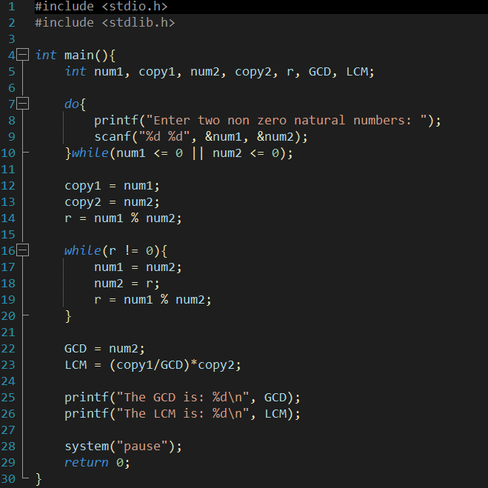
Execution : Put a screenshot of the execution like in the course
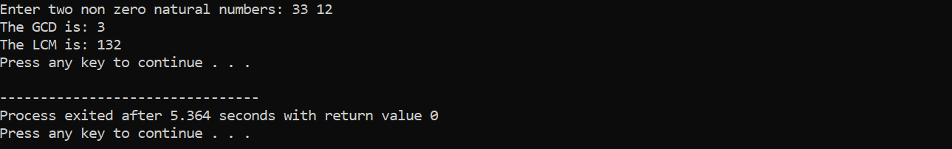
- Given an array T of N non-zero natural numbers , write an algorithm to:
- compute and display the GCD and LCM of all elements
- display all pairs of elements whose GCD is greater than 1.
Analysis :
Input | Processing | Output
Algorithm:

C / Python Code : Put a screenshot of the course like in the course

Execution : Put a screenshot of the execution like in the course

Module 03: Real Numbers and Decomposition (Focus: arithmetic manipulation, logic, precision)
- Display the mirror of a natural number.
Example: 2358 → 8532
Analysis :
Input | Processing | Output
Algorithm:

C / Python Code : Put a screenshot of the course like in the course

Execution : Put a screenshot of the execution like in the course
- Given a real number, extract:
- the integer part
- the fractional part.
Analysis :
Input | Processing | Output
Algorithm:

C / Python Code : Put a screenshot of the course like in the course

Execution : Put a screenshot of the execution like in the course

- Transform a real number into exponential form.
Example: 2601 → 2.601 × 10³
Analysis :
Input | Processing | Output
Algorithm:

C / Python Code : Put a screenshot of the course like in the course

Execution : Put a screenshot of the execution like in the course

- Given an array of real numbers, display those whose integer part is the mirror of the fractional part.
Analysis :
Input | Processing | Output
Algorithm:

C / Python Code : Put a screenshot of the course like in the course

Execution : Put a screenshot of the execution like in the course

Module 04: Matrices (Focus: 2D arrays, symmetry logic)

  - Write an algorithm to check whether a square matrix of order N is symmetric.
  - If the matrix is symmetric:
- Display the non-duplicate values
- Display their positions.
Analysis :
Input | Processing | Output
An integer N (size of the square matrix, 1 ≤ N ≤ 20)  Elements of the matrix | Initialize a flag is symmetric = true.  Check symmerty: Compare each element above the diagonal with its mirrored element.  If any pair is different, set isSymmetric = false.  If symmetric:  Create a list uniqueValues[].  Go through all elements:  If an element is not already in uniqueValues[], add it and display its value and position  If not symmetric : Display a message “Matrix is not symmetric”. | If symmetric: List of non-duplicate value and their positions  If not symmetric: message "Matrix is not symmetric"
Algorithm:

C / Python Code : Put a screenshot of the course like in the course
Execution : Put a screenshot of the execution like in the course

